**View account details, given an account ID. (POST /cash-management/accounts)**

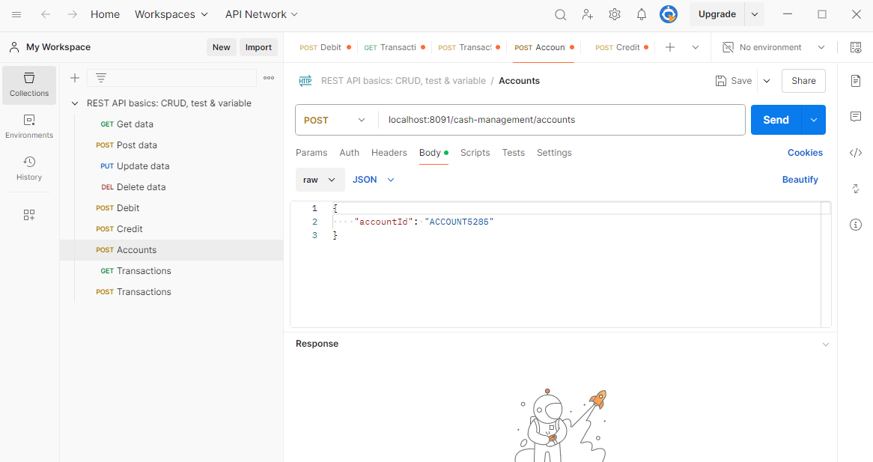

**credit the Account (POST /cash-management/credit)**

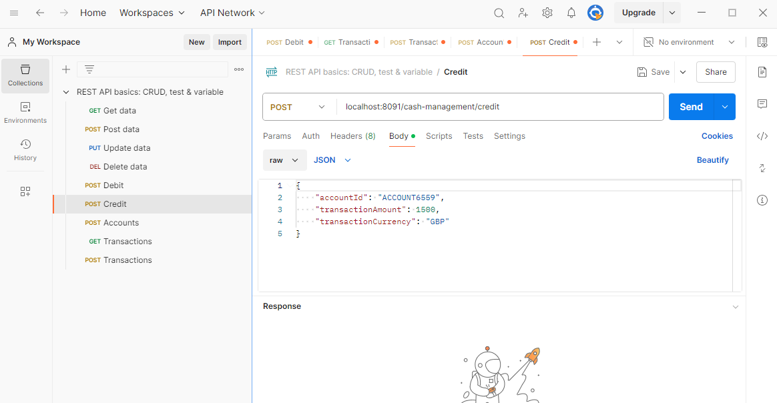

**Debit the account (POST /cash-management/debit)**

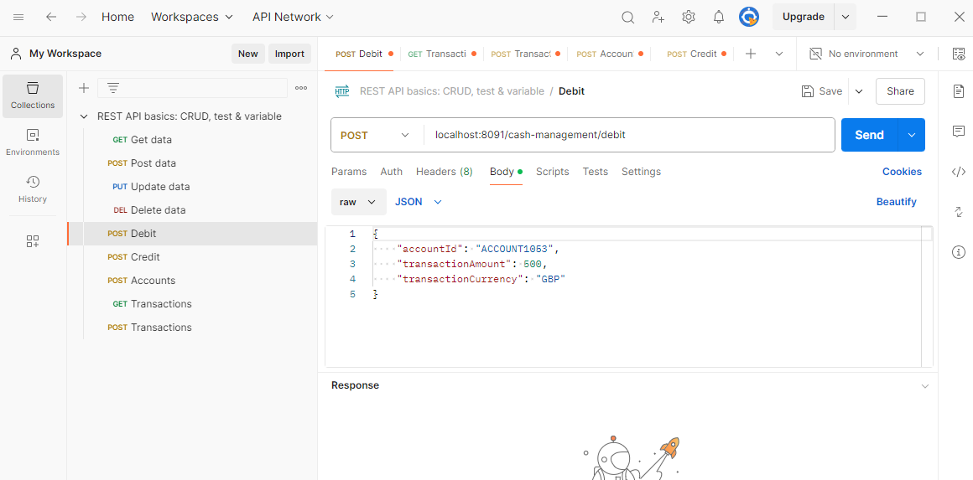

**View transactions for a given account Id (POST /cash-management/transactions)**

